1) Install nginx and run nginx on port number 81.

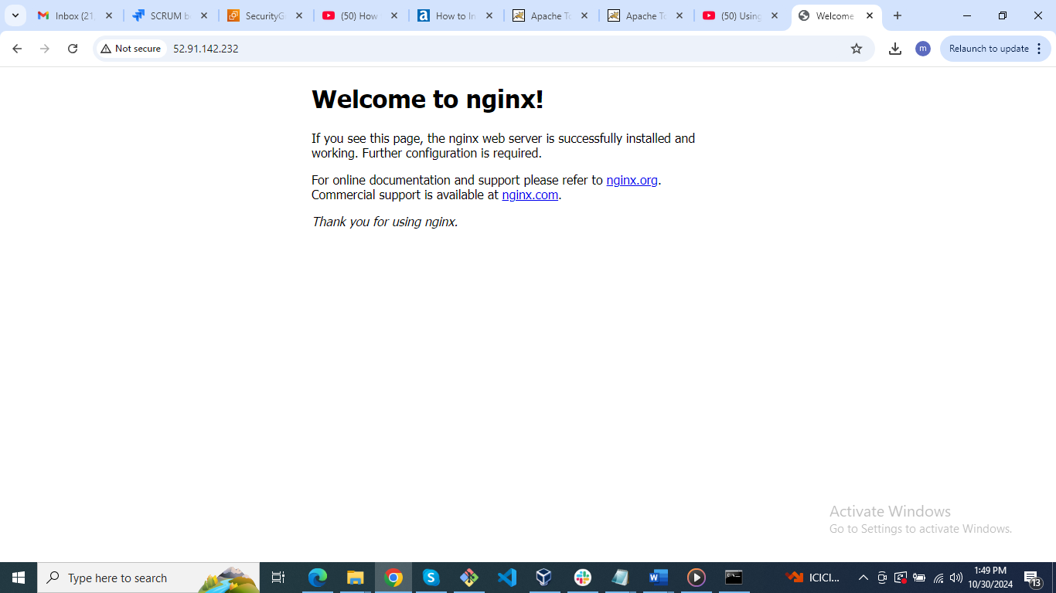

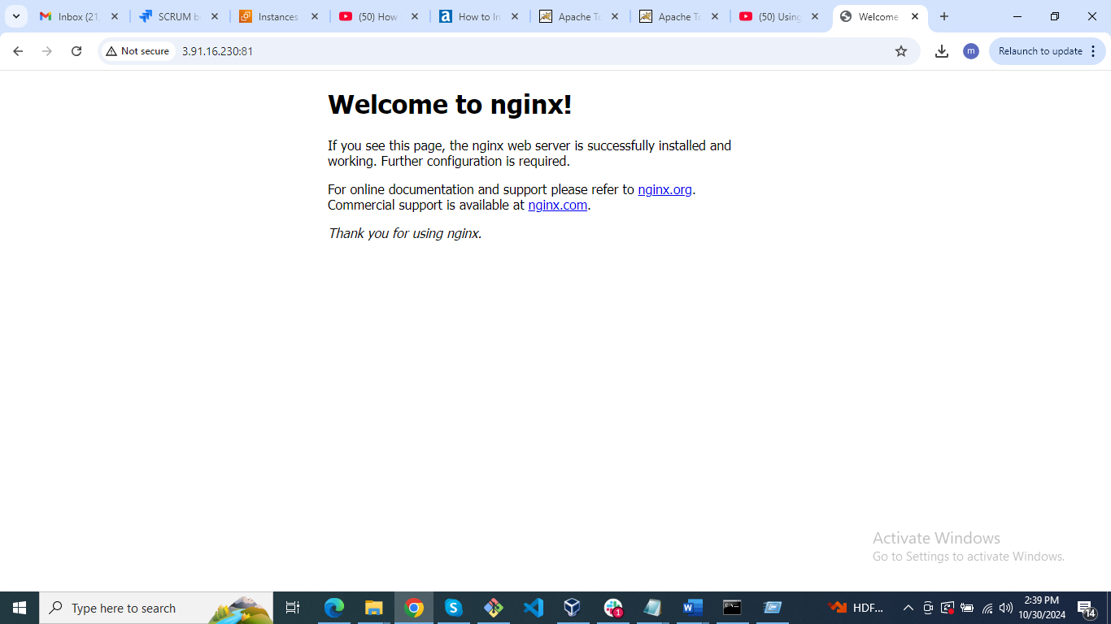

2) Deploy a sample index.html file on nginx

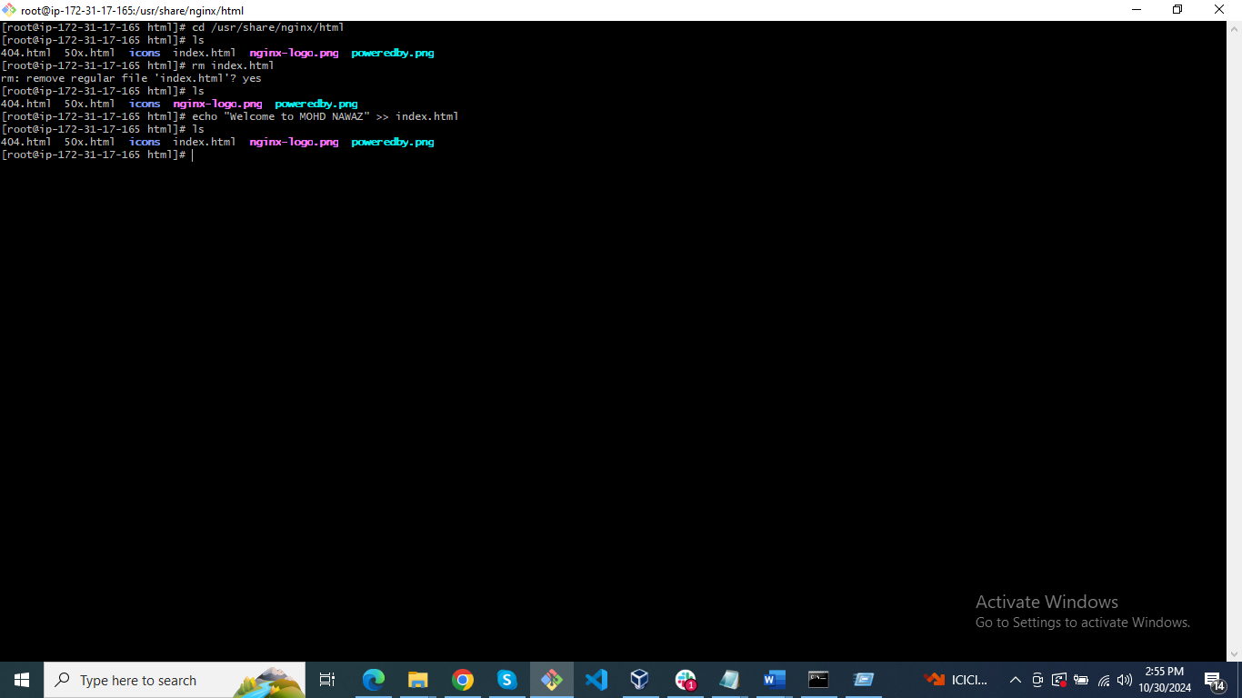

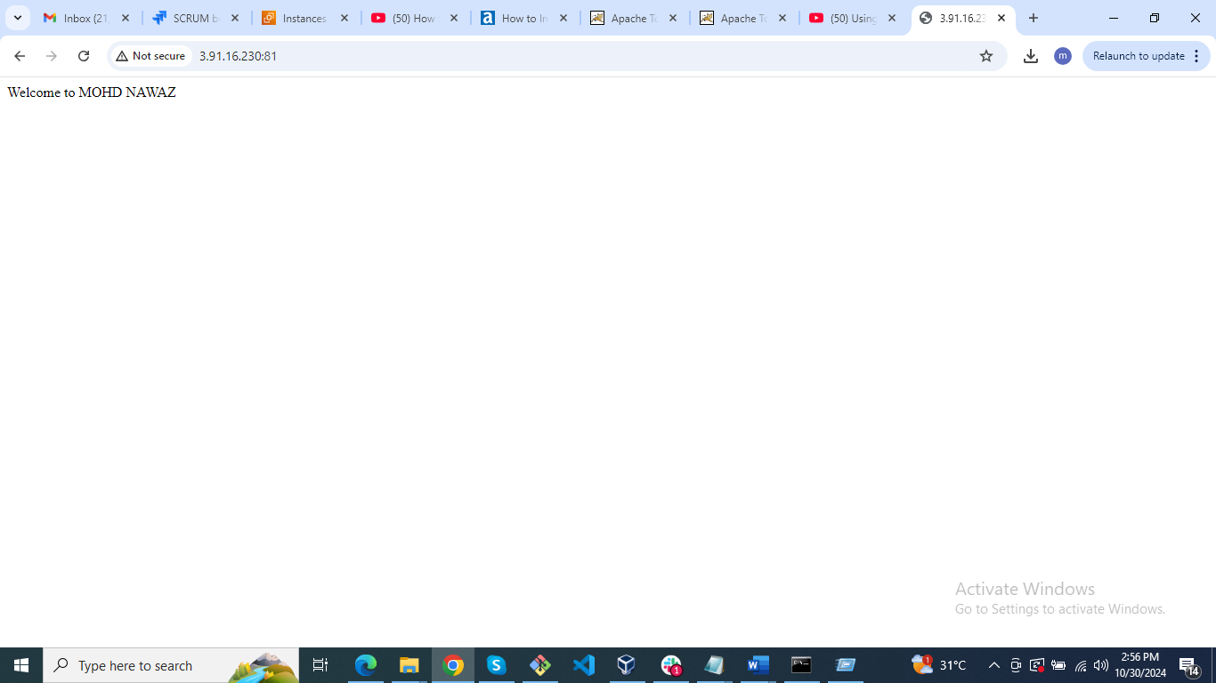

5) Install Apache tomcat on port number 8082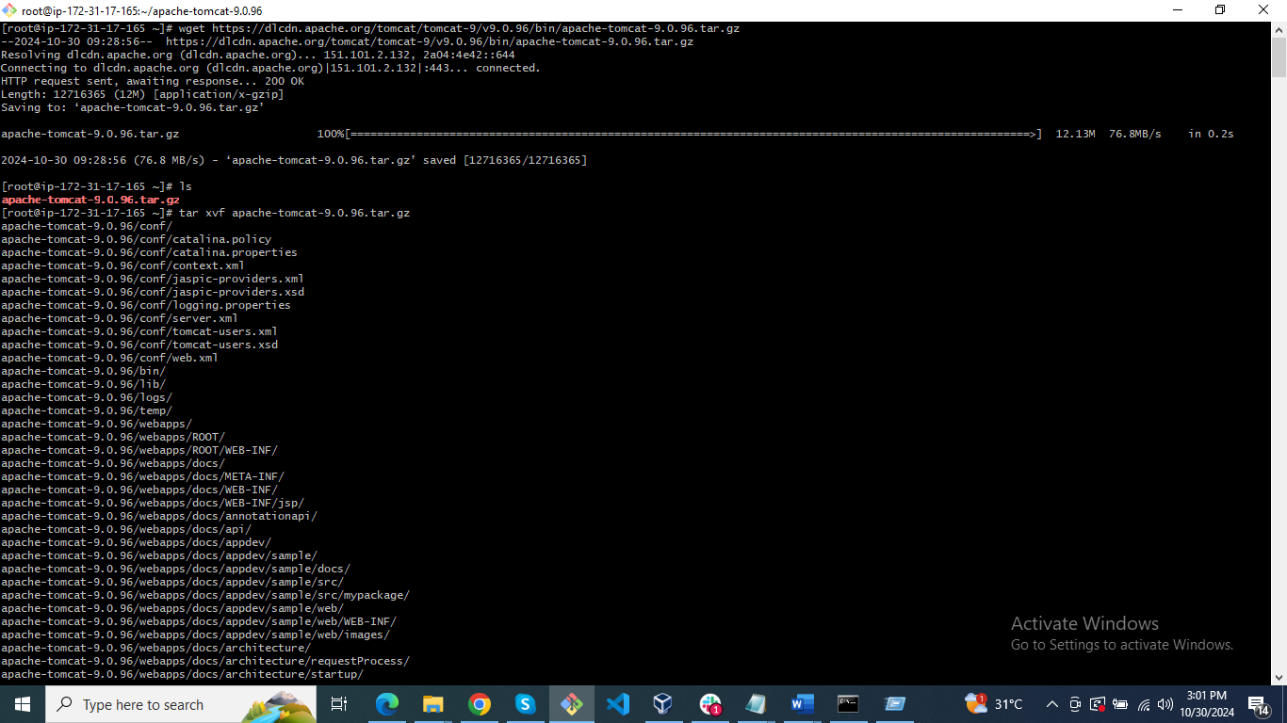

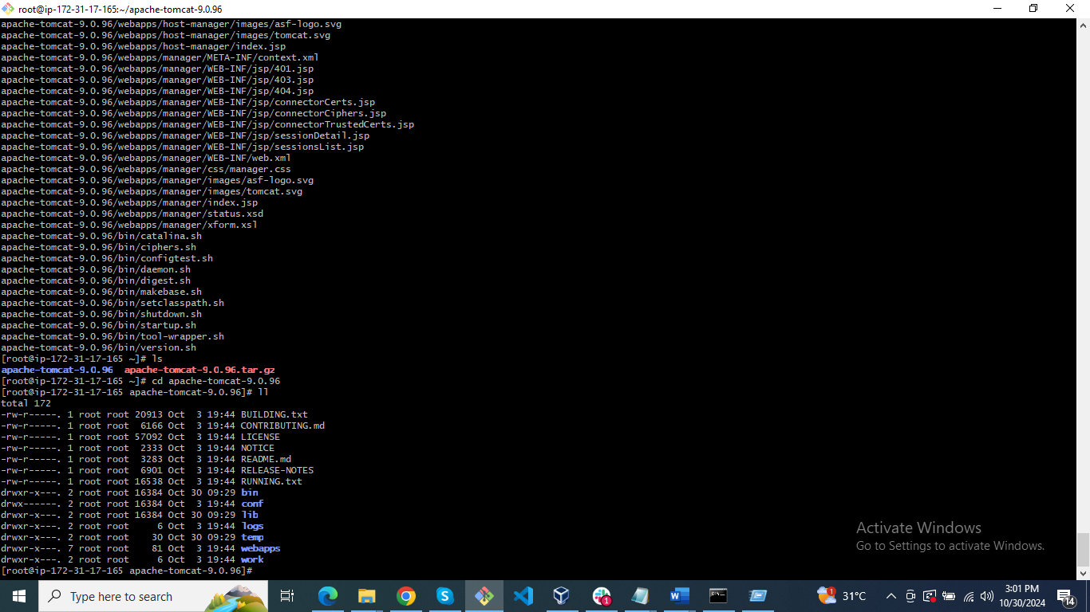

While starting the service it shows error on java

So, yum install tomcat9

<https://downloads.apache.org/tomcat/tomcat-9/v9.0.97/bin/apache-tomcat-9.0.97.tar.gz.sha512>

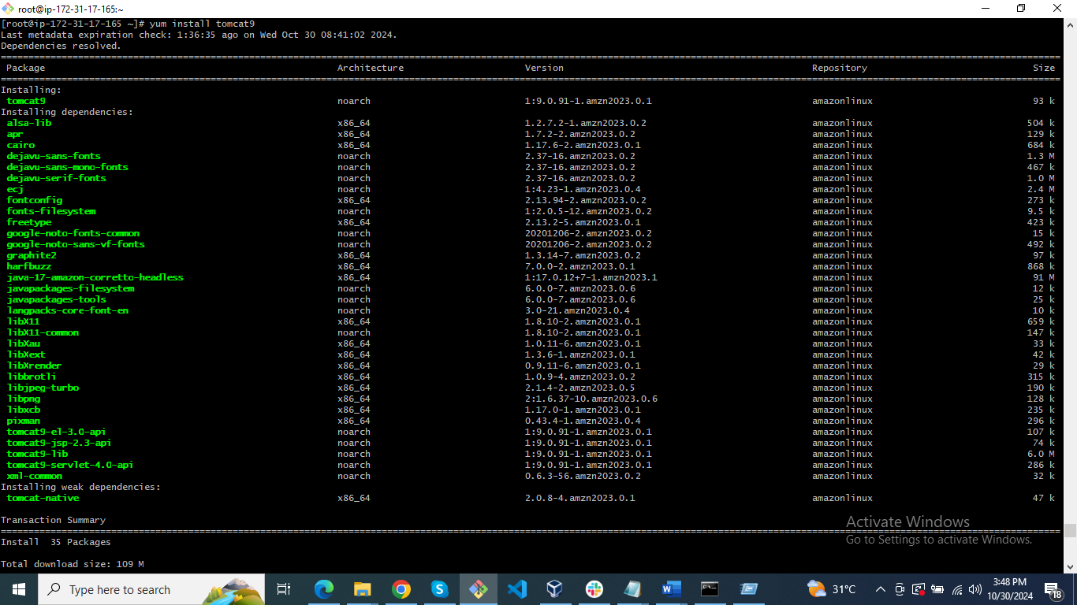

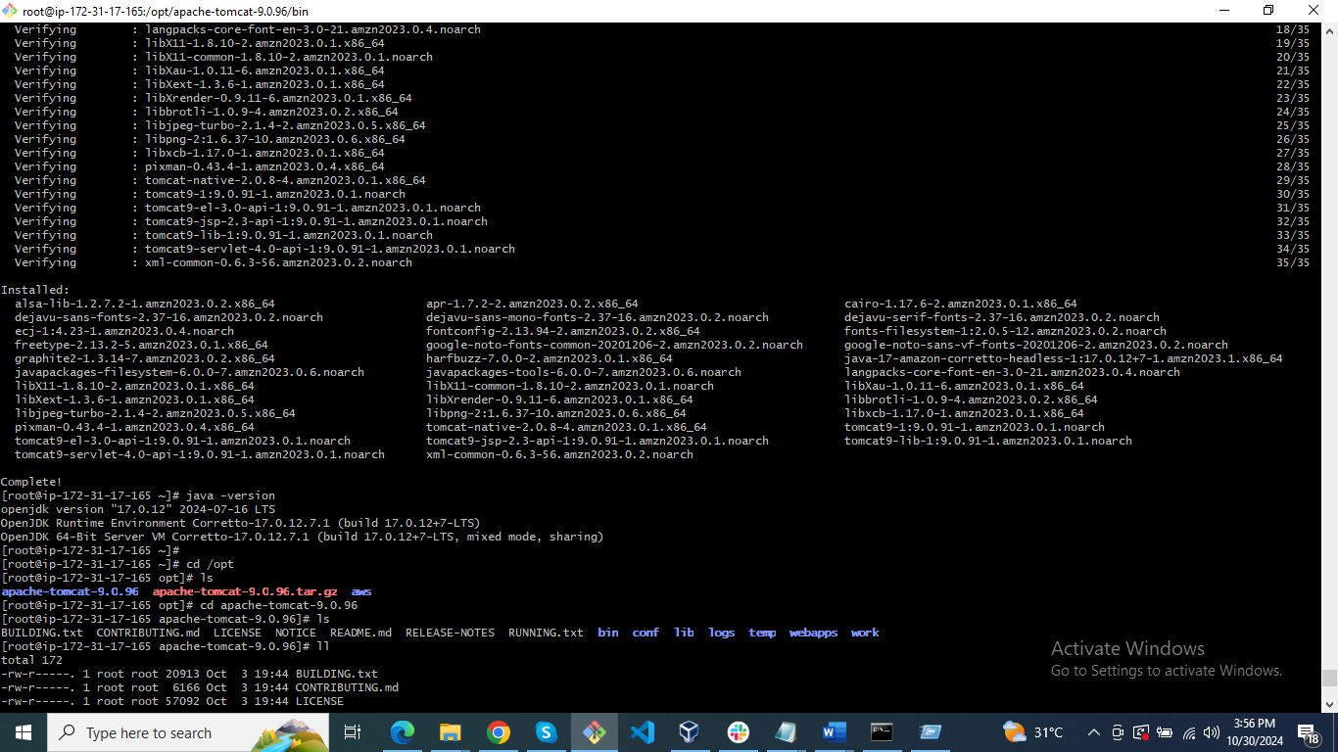

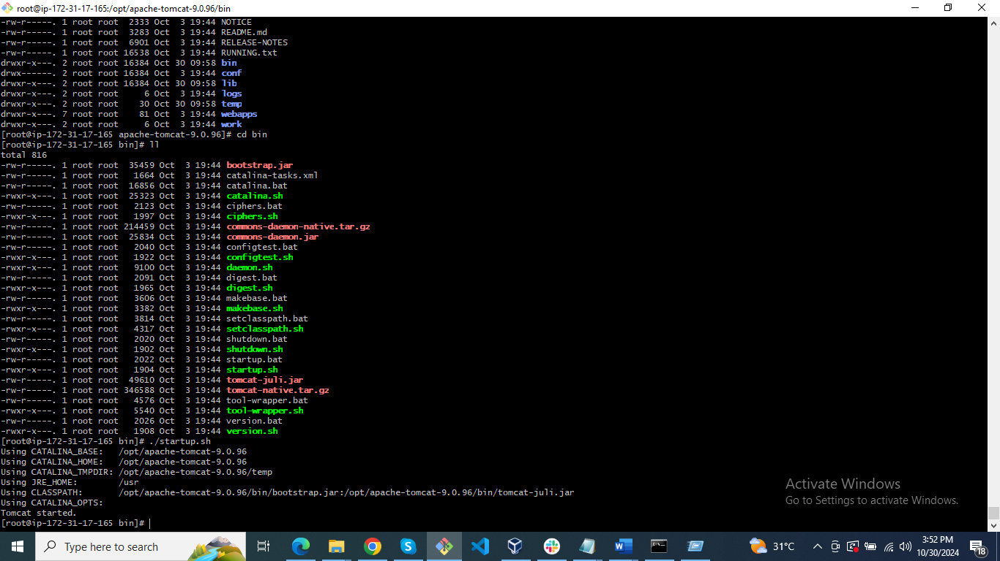

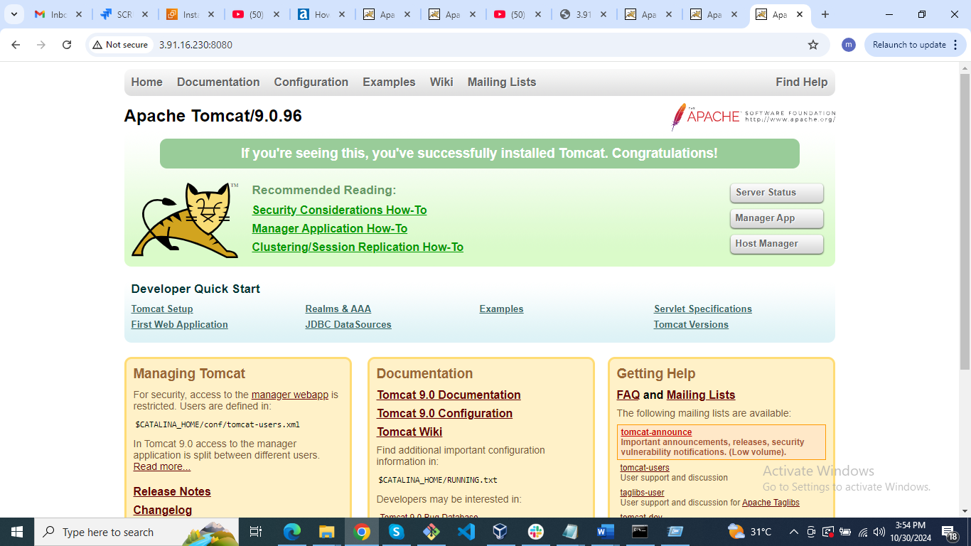

Change the port

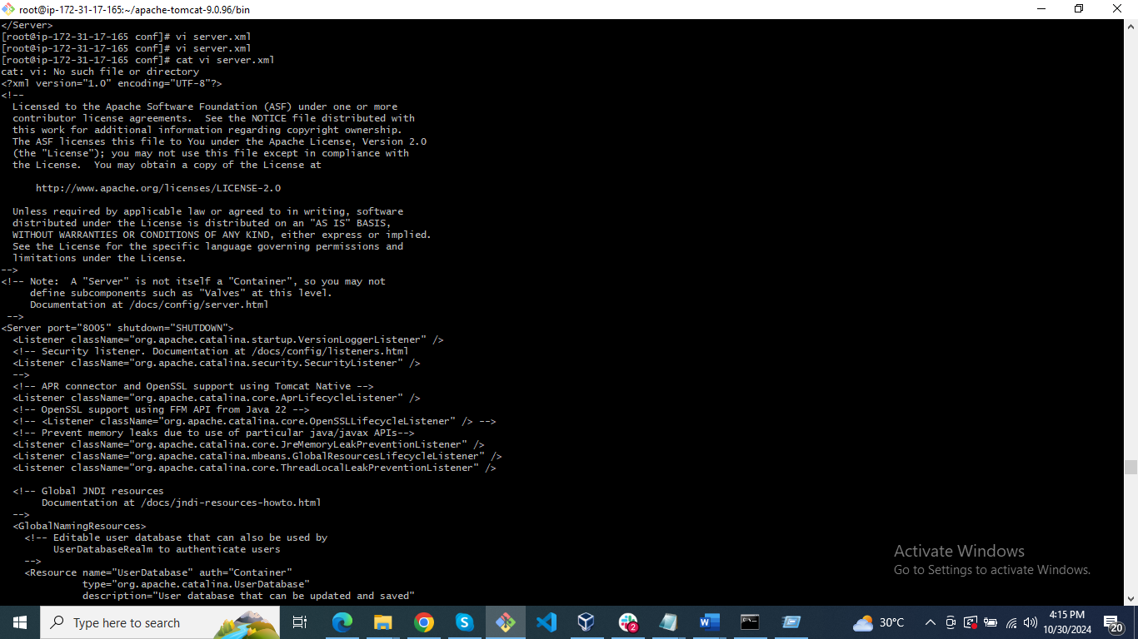

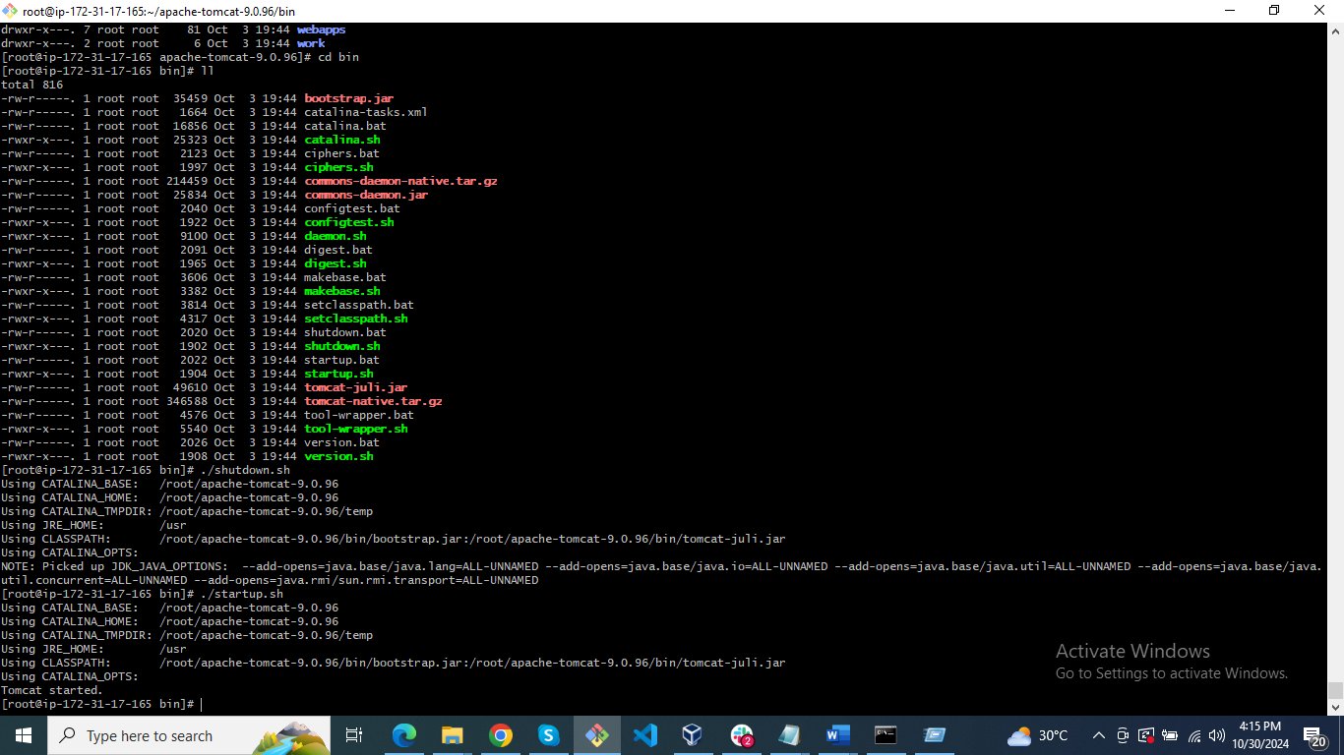

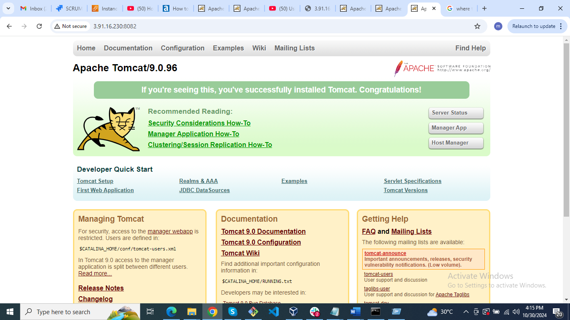

3) Install Apache and run Apache on port number 82

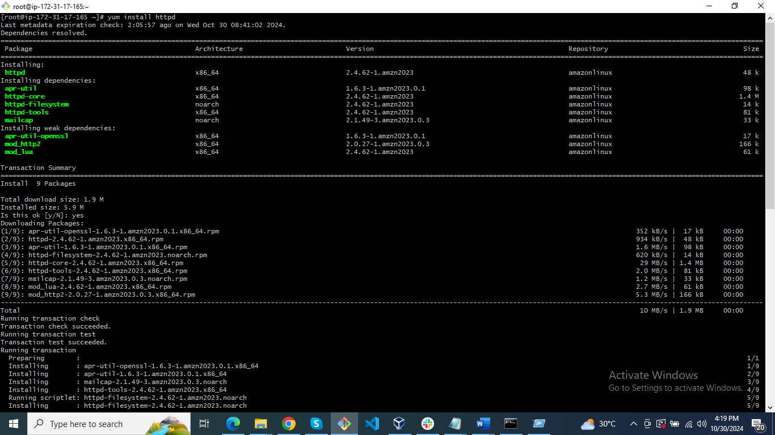

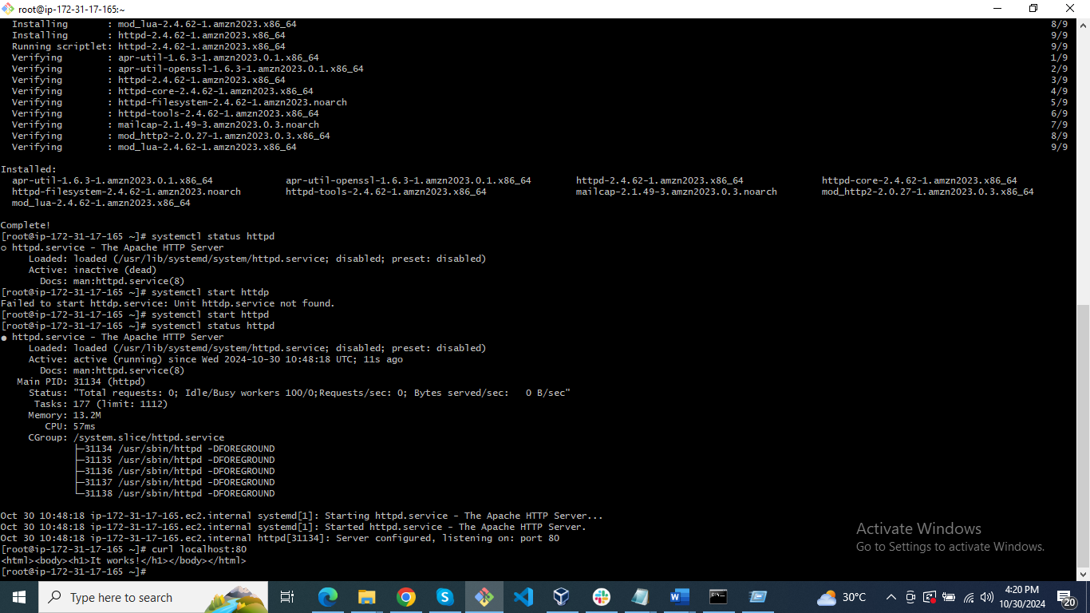

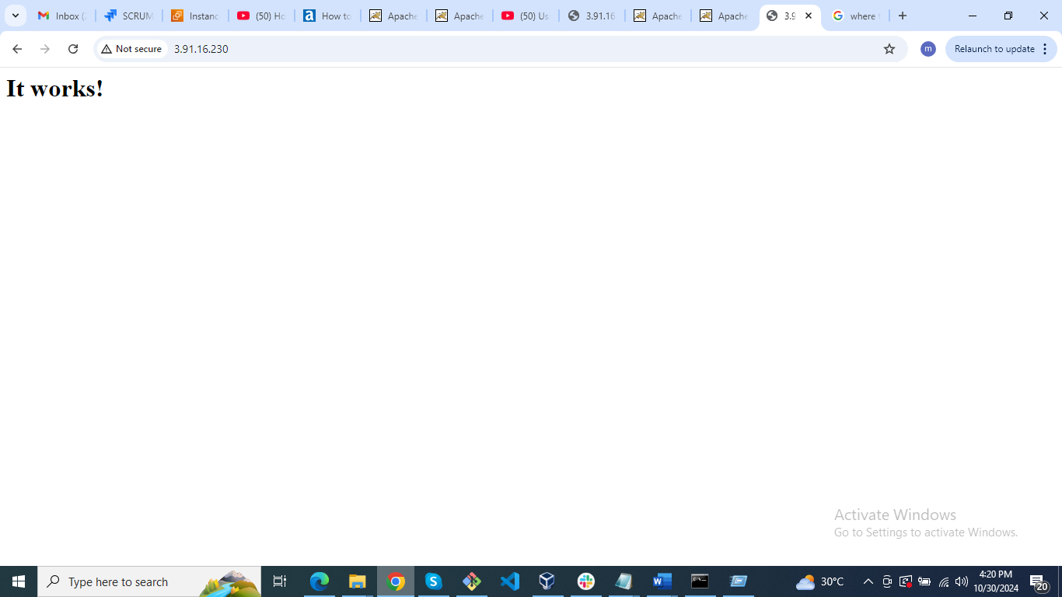

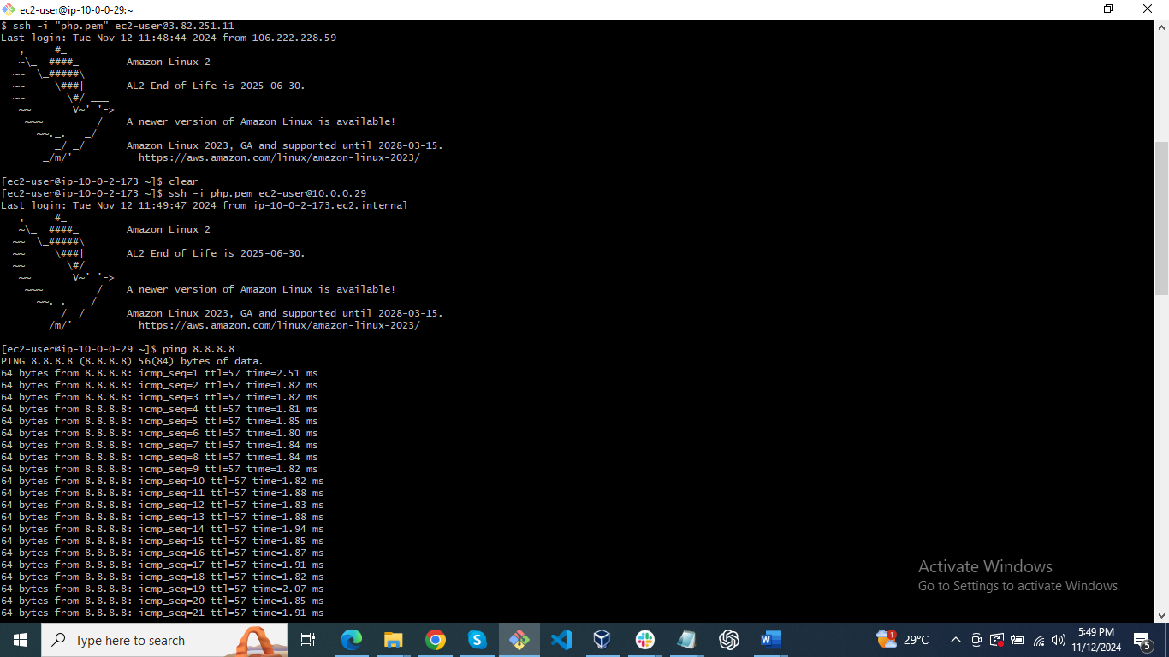

4) Deploy a sample index.html file on Apache

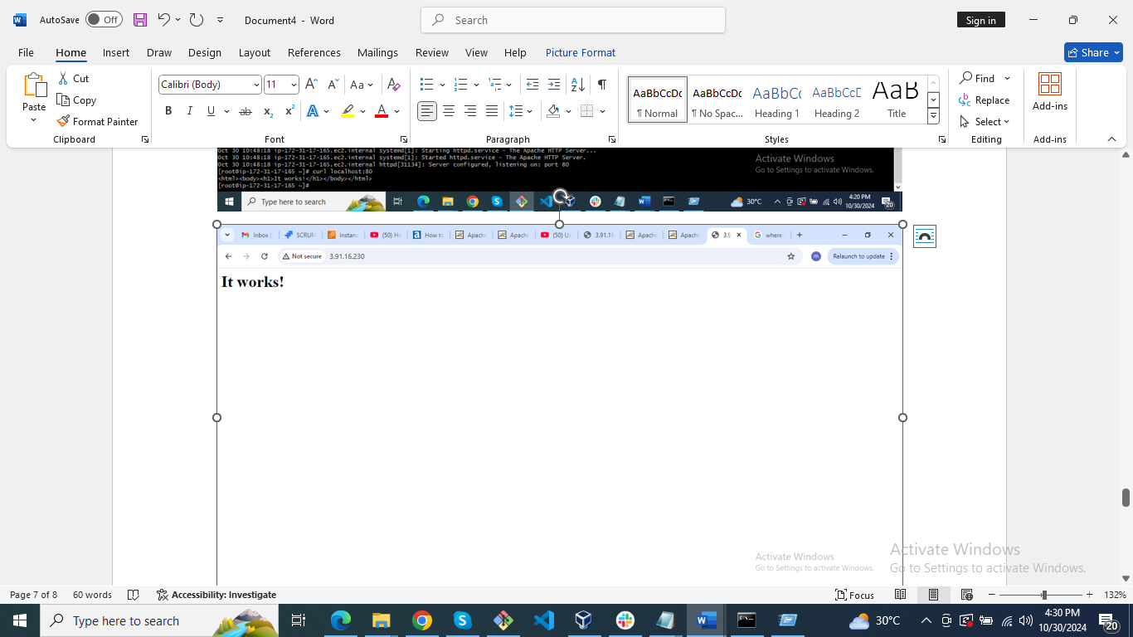

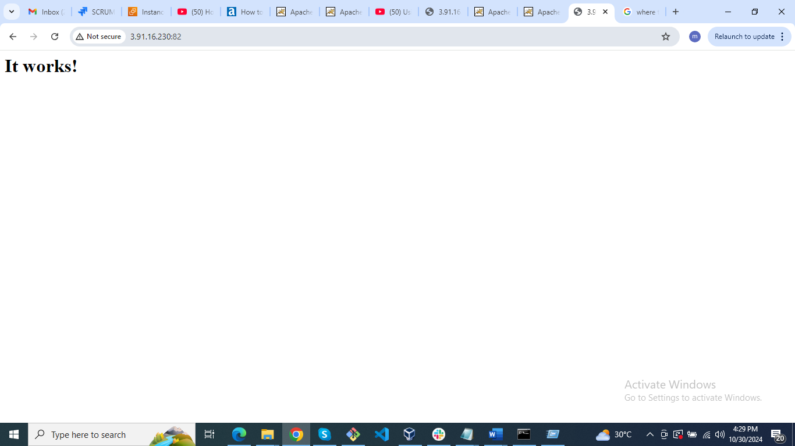

6) Deploy a sample app on webapps

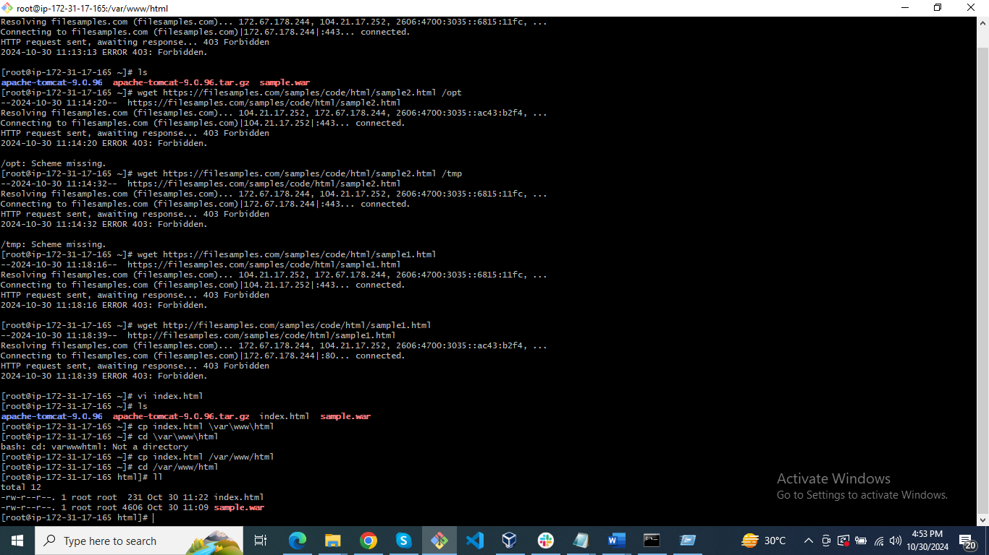

7) Create a tomcat.service file for tomcat.

Create a file called tomcat.service in the location of etc/system/system/tomcat.service

[Unit]  
Description=Tomcat - instance %i  
After=syslog.target network.target  
  
[Service]  
Type=forking  
  
User=root  
Group=root  
  
ExecStart=/opt/apache-tomcat-9.0.78/bin/startup.sh #check the path of startup.sh  
ExecStop=/opt/apache-tomcat-9.0.78/bin/shutdown.sh #check the path of shutdown.sh  
  
RestartSec=10  
Restart=always

